**IFT 266 Introduction to Network Information Communication Technology (ICT)**

**Lab 42**

**Tunneling with IPv6 across an IPv4 Network**

Co-authored by Richard Bison

**After you complete each step, Double click on the Check box and select “Checked”  
or**

**Attach a screenshot where required**

**Objective**Demonstrate the use of the tunneling to transmit IPv6 packets across a working IPv4 network which only supports IPv4 devices and router.

1. Set up the following topology in Packet Tracer  
     
   Once you apply the configurations below, all the connections will turn green.

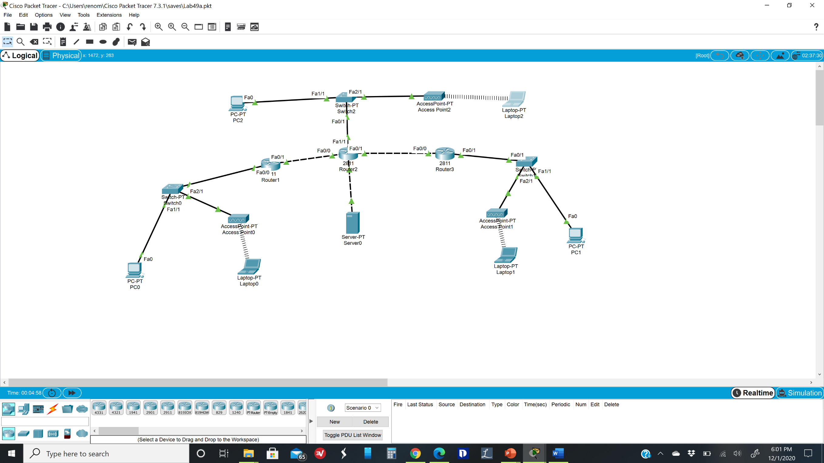



**Note:** You may need to add additional modules to the routers and laptops to connect the devices. (Hint: Use module “NM-2FE2W” for “Router 2”. Make sure to use “Port 1” to configure both “Access Point” devices. Finally, replace the laptop’s ethernet card with the “Linksys-WPC300N”)

Completed  (Double click on Check box and select “Checked”)

1. Set up the IPv4 and IPv6 addresses on PC0, PC1, PC2, Laptop0, Laptop1, Laptop2 and Server0:



|  |  |
| --- | --- |
| **Laptop0**  IP address: 10.1.1.3  Subnet Mask: 255.255.255.0  Default Gateway: 10.1.1.1  IPv6 Address: 2001:1:1:1::3/64  IPv6 Gateway: 2001:1:1:1::1  SSID: donkey1  Authentication: WEP  WEP key: 0123456789 | **PC0**  IP address: 10.1.1.2  Subnet Mask: 255.255.255.0  Default Gateway: 10.1.1.1  IPv6 Address: 2001:1:1:1::2/64  IPv6 Gateway: 2001:1:1:1::1 |
| **Laptop1**  IP address: 10.4.4.3  Subnet Mask: 255.255.255.0  Default Gateway: 10.4.4.1  IPv6 Address: 2001:4:4:4::3/64  IPv6 Gateway: 2001:4:4:4::1  SSID: donkey2  Authentication: WEP  WEP key: 9876543210 | **PC1**  IP Address 10.4.4.2  Subnet Mask: 255.255.255.0  Default Gateway: 10.4.4.1  IPv6 Address: 2001:4:4:4::2/64  IPv6 Gateway: 2001:4:4:4::1 |
| **Laptop2**  IP address: 10.6.6.3  Subnet Mask: 255.255.255.0  Default Gateway: 10.6.6.1  SSID: donkey3  Authentication: WPA2-PSK  PSK Pass Phrase: AbCdEfGhIj | **PC2**  IP Address 10.6.6.2  Subnet Mask: 255.255.255.0  Default Gateway: 10.6.6.1  IPv6 Address: 2001:5:5:5::2/64  IPv6 Gateway: 2001:5:5:5::1 |
| **Server0**  IP address: 10.5.5.2  Subnet Mask: 255.255.255.0  Default Gateway: 10.5.5.1 | |

Completed  (Double click on Check box and select “Checked”)



1. Setup interfaces on **R1** for IPv4 and IPv6.  
     
   Configure the interface: FastEthernet 0/0; with an IPv4 address and an IPv6 address:

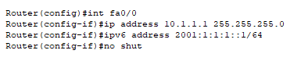

Configure the interface: FastEthernet 0/1; with an IPv4 address only:

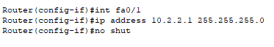

Set the ipv4 route and enable IPv6 routing





Completed  (Double click on Check box and select “Checked”)



1. Setup **R2**. We will only setup IPv4 addresses this time:

Configure fa0/0, fa0/1, fa1/0 and fa1/1:



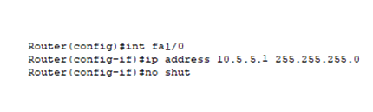



Set the IP routes:



Completed  (Double click on Check box and select “Checked”)

1. Try to ping PC2’s IPv4 address from Server0.   
     
   It should work, otherwise troubleshoot.

Show an image of your successful ping here

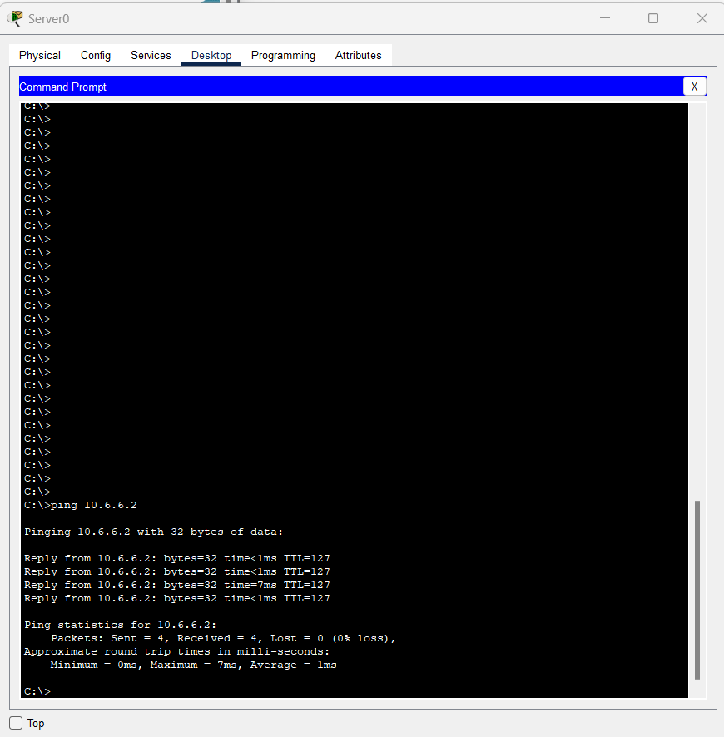



1. Set up **R3**. This process is the same as R1.

Configure fa0/0 (or whichever interface is connected to R2) with IPv4 only:



Configure fa0/1 with both IPv4 and IPv6:



Set up routing for IPv4 and IPv6:



Completed  (Double click on Check box and select “Checked”)



1. Go into Access Point 0, 1 and 2, and set the SSID to “Donkey1”, “Donkey2”, and Donkey3” respectively; and enable WEP for both Laptop0 and Laptop1 and enter the 10-digit keys provided before. Finally, enable WAP2-PSK for Laptop2 and use the PSK Pass Phrase that was given earlier.

Completed  (Double click on Check box and select “Checked”)



1. Now, try pinging PC1’s IPv4 address from Laptop0. If the IPv4 settings on each device are configured correctly, this will work.

Show an image of your successful ping here

1. This time, trying pinging PC1’s IPv6 Address from Laptop0. This will **not** work, as R2 is not configured for IPv6.

Show an image of your unsuccessful ping here

**Current Status**

Now that we have completed setting up our IPv4-only network, how will Laptop0 communicate with PC1?   
  
We can create an IPv6 tunnel over the IPv4 network.   
  
Four things must be taken into consideration for us to create the tunnel,:

Tunnel source

Tunnel destination

Specifying tunnel mode

Configuring IPv6 tunnel address

Completed  (Double click on Check box and select “Checked”)



1. At this point, we will set up a tunnel which allows R1 and R3 to communicate with IPv6, even though R2 uses only IPv4.

Configure the tunnel and routing on R1

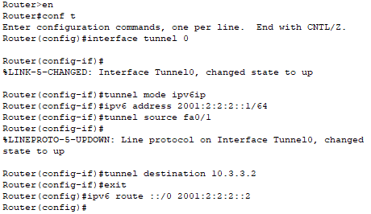

Completed  (Double click on Check box and select “Checked”)



1. Configure the tunnel and routing on R3

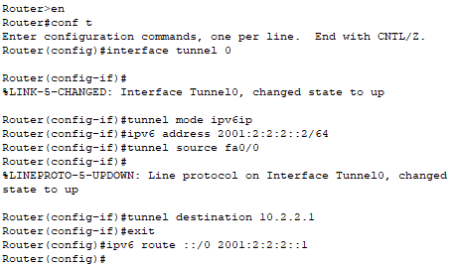

Completed  (Double click on Check box and select “Checked”)



1. Try pinging PC1’s IPv6 address, now, from Laptop0.   
     
   It should work, otherwise troubleshoot.

We will now change the SSID and enable WEP authentication on the laptops.

Show an image of your successful ping here

